CDAC Mumbai PG-DAC MARCH 24

Assignment No- 1

1. Write a program that takes a numerical grade as input and outputs the corresponding letter grade using if-else statements.

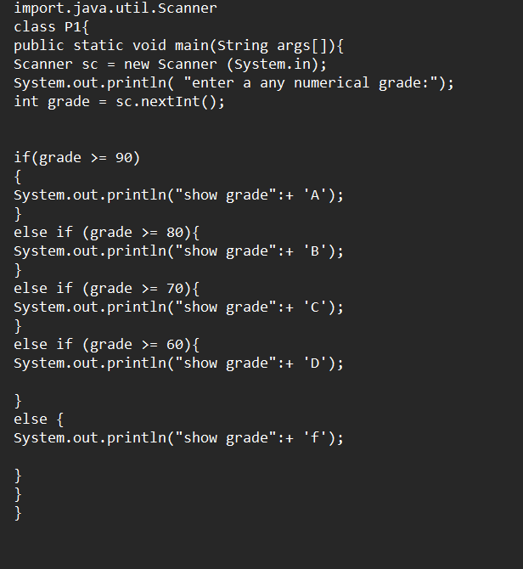

1. Write a program that checks if a given year is a leap year or not using both if-else and switch-case.

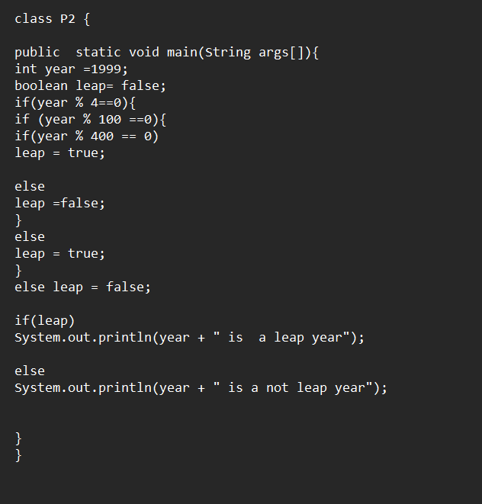

1. Implement a simple calculator program that takes two numbers and an operator (+, -, \*, /) as input and performs the operation using switch-case.

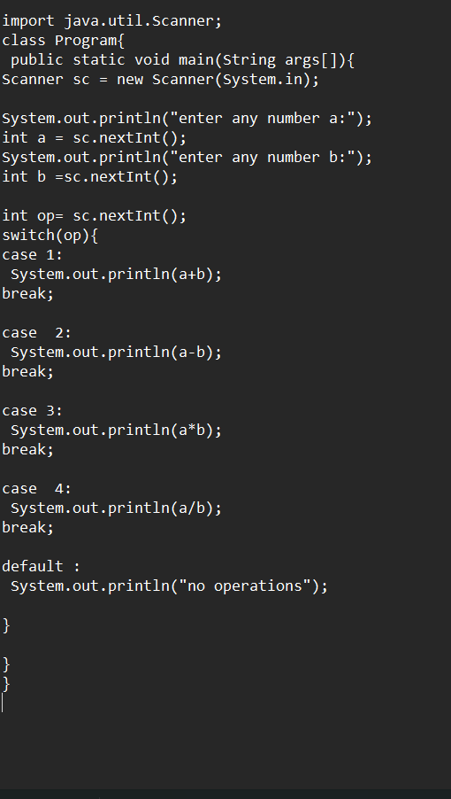

1. Write a program that takes a number representing a weekday (1-7) and prints the name of the weekday using switch-case.

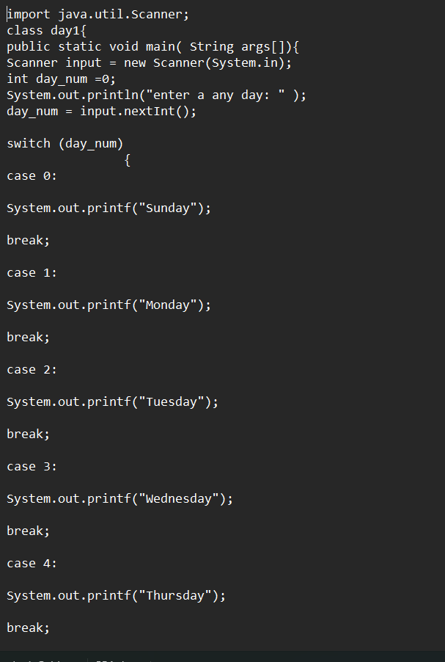

1. Write a program that takes a character as input and determines whether it’s a vowel or a consonant using if-else.

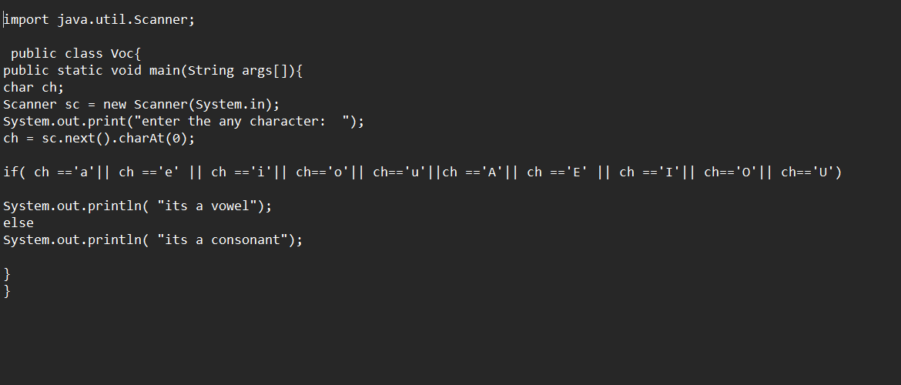

1. Implement a program that calculates the Body Mass Index (BMI) based on height and weight input using if-else to classify the BMI int categories (underweight, normal weight, overweight, etc.).

